Real Time Operating System

Name – Haygriv Bansal
Roll No – 2410994538
Group – X2
Course Coordinator – DR Amit Kumar
Course Code – 24ECE4202

Problem Statement:

The given problem statement was Industrial Emergency Stop Reporter , we have configure onboard Pins to display message on external USART software serial port utility . In this problem statement solution we configured onboard Pin PA5 , PC13 , PA0 , PA2 , PA3 and
HSE AND BSE as BYPASS CLOCK Source.

Block Diagram:

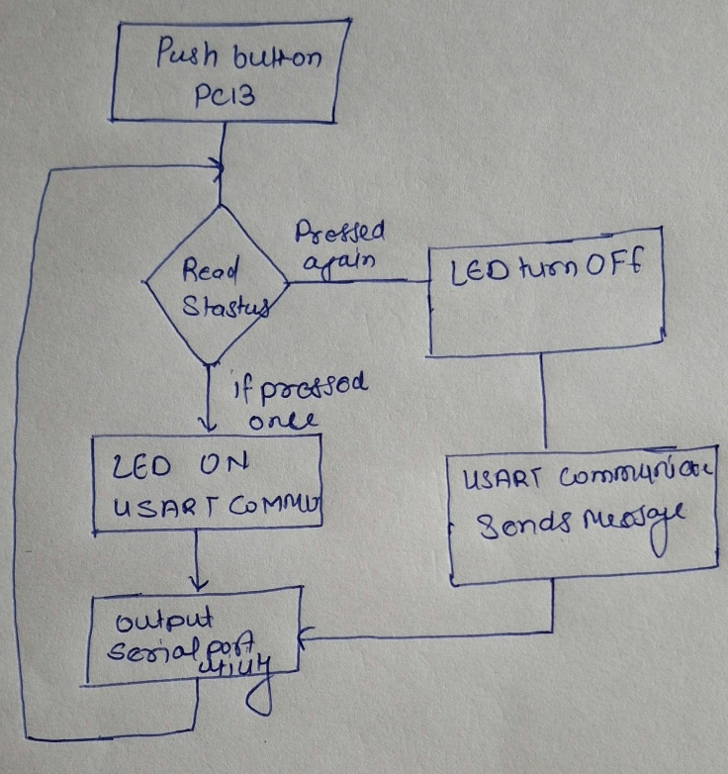

Pin Mapping:

Function | STM32 Pin | Mode Configuration | Description
Emergency Button | PC13 | GPIO Input with Pull-Up | Detects button press (Active LOW)
RED LED | PA5 | GPIO Output Push-Pull | Indicates emergency condition
UART TX | PA2 | USART2_TX (AF mode) | Transmit messages to PC
UART RX | PA3 | USART2_RX (AF mode) | Receive "RESET" command
Timer (Debounce) | TIM2 | Basic Timer (200 ms delay) | Software debounce control

System Configuration:

Step 1:

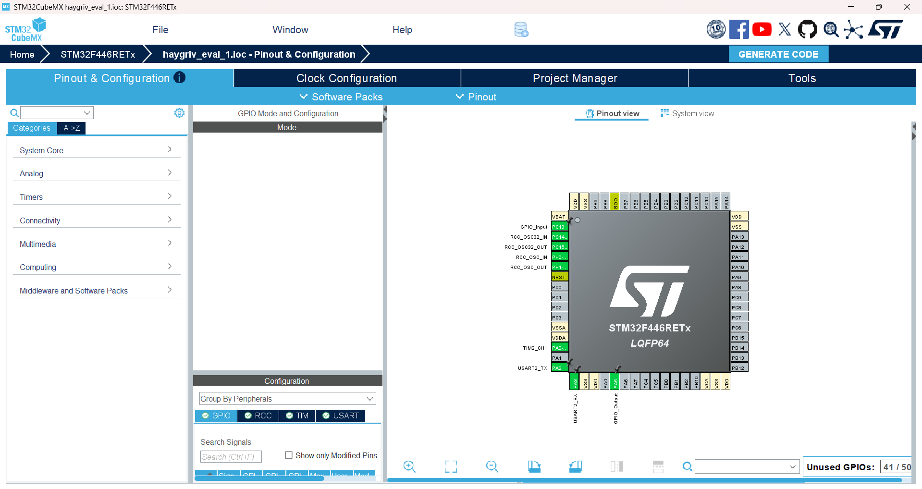
Configure Pin PA5 as GPIO output pin and Pin PC13 as GPIO input pin
Step 2:

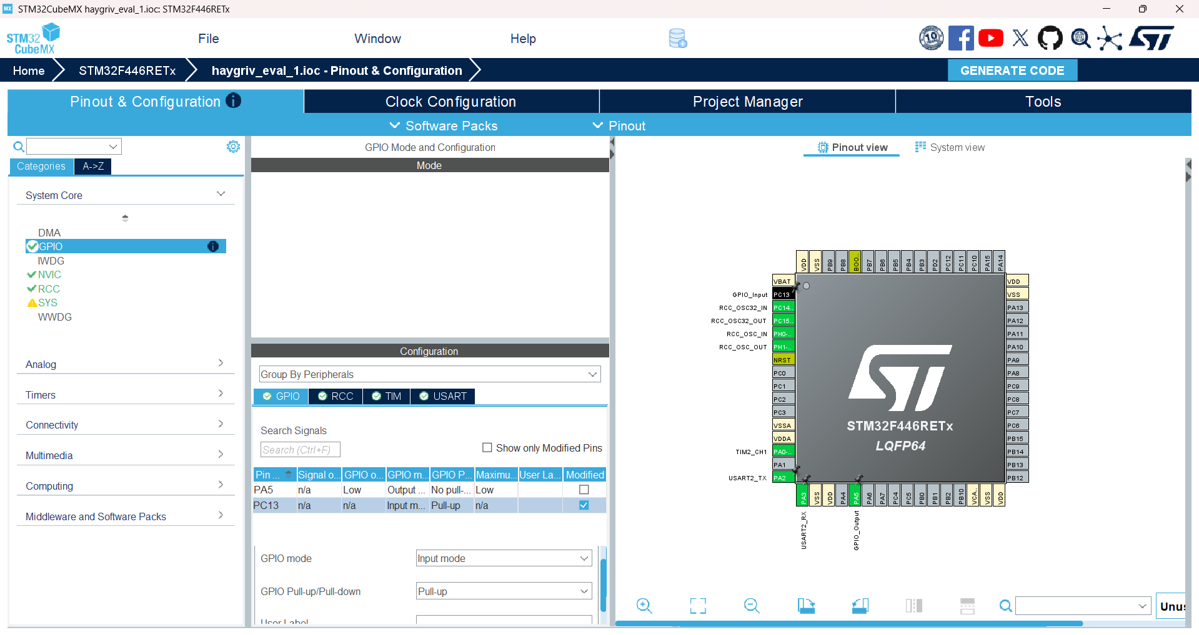
Go to system core and select PC13 pin and set GPIO mode as Pull up mode

Step 3:

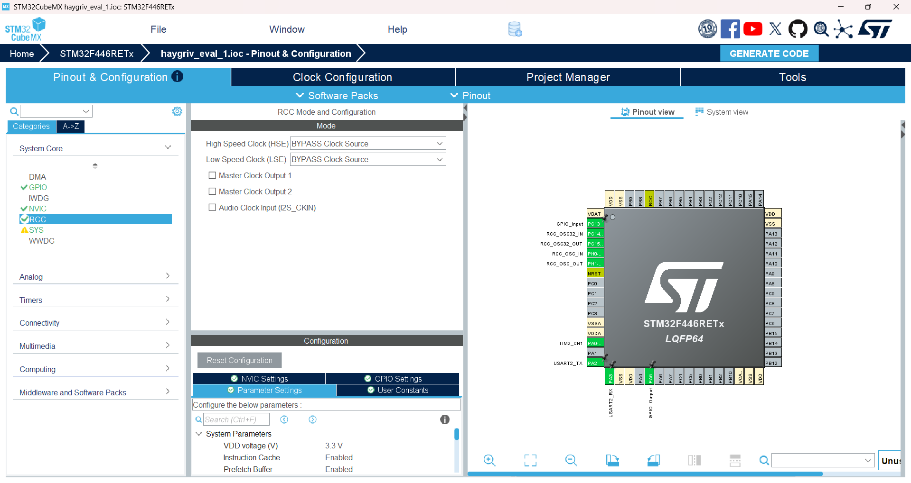
Go to system core go to RCC and enable HSE and BSE as BYPASS Clock Source

Step 4:

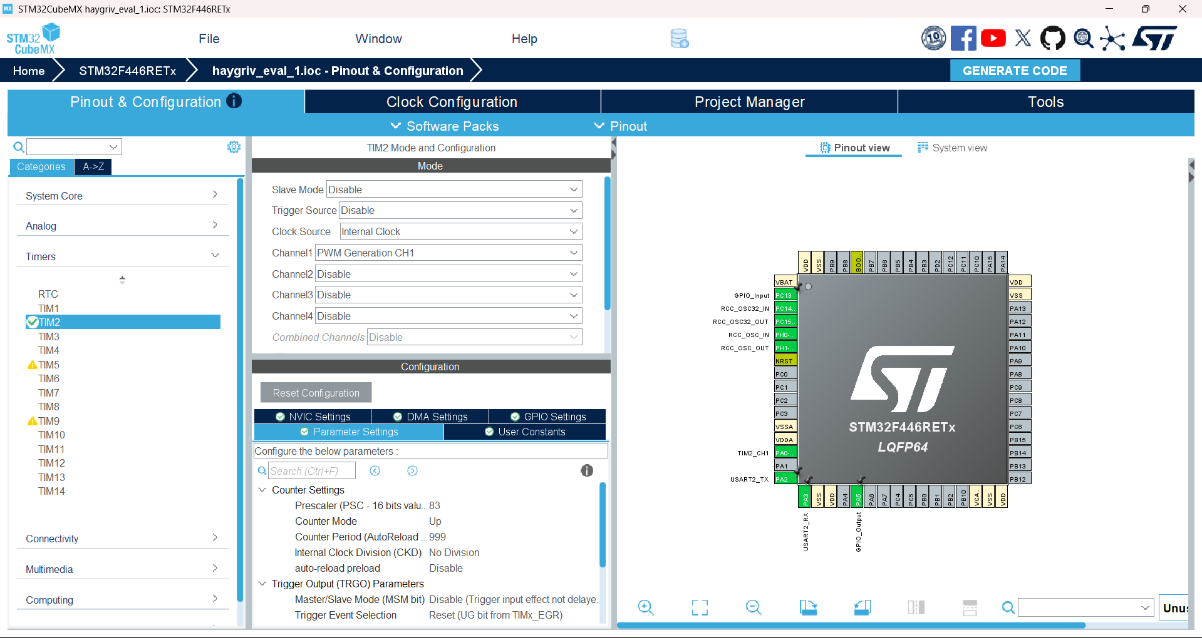
Go to Timers and select TIM2 , enable Channel 1 as PWM Generation CH1 and clock source as internal clock , then give values to Prescaler = 84 -1 and ARR = 1000 – 1 .

Step 5:

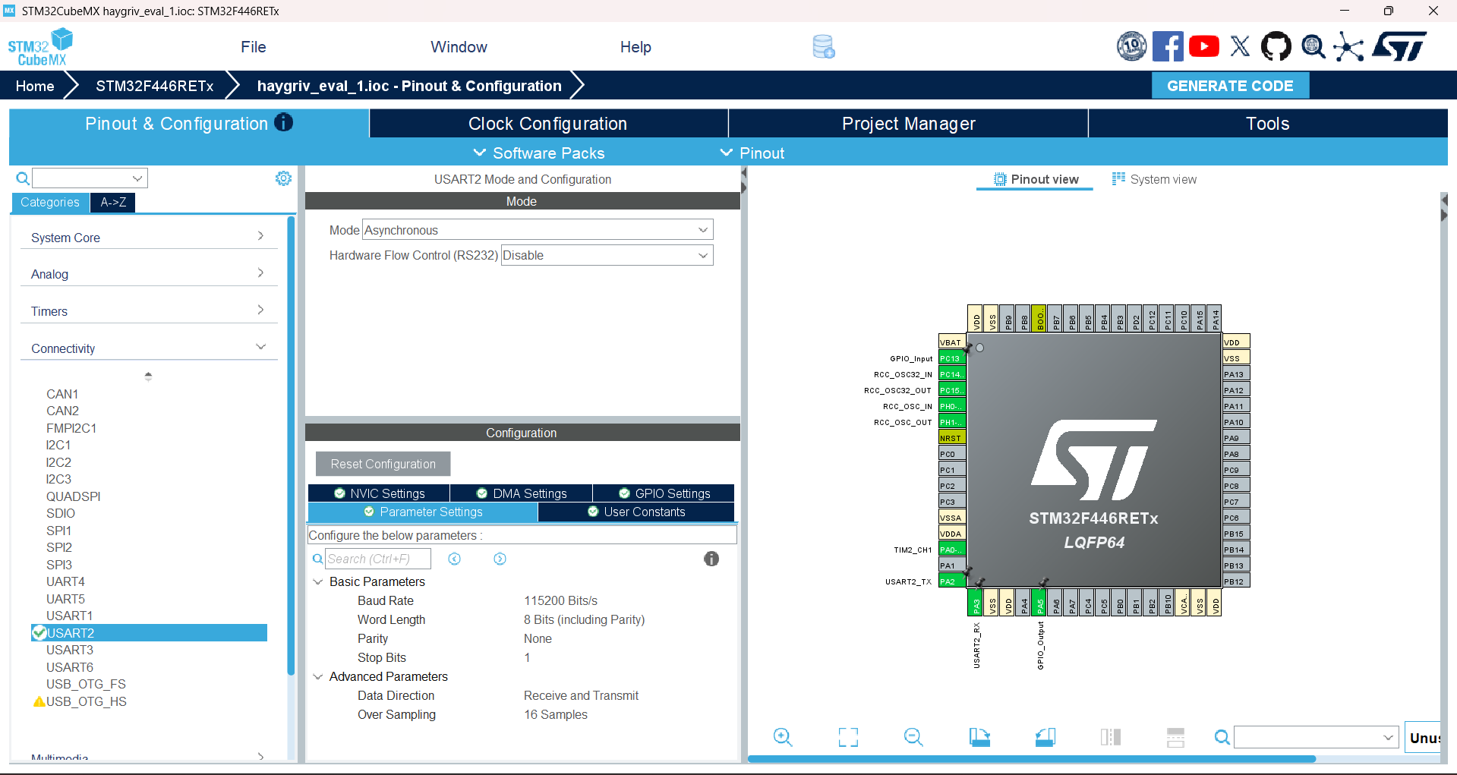
Go to Conectivity and select USART2 and enable its mode as Asynchronous and give the value of
Baud Rate = 11520
Word Length = 8bits
Parity = None
Stop Bits = 1

Step 6:

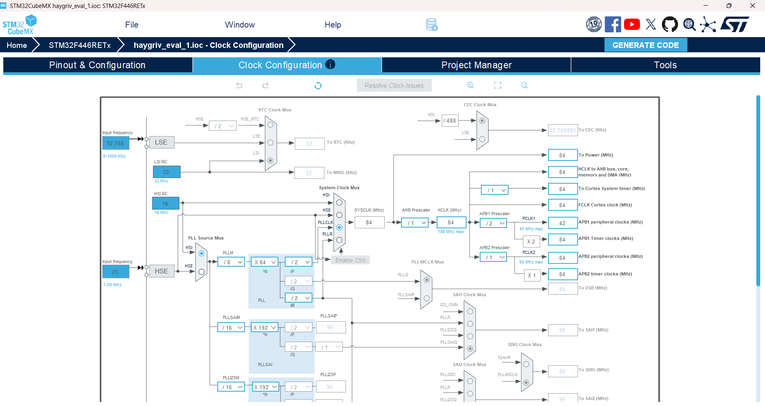
Go to clock configuration and edit the value of HCKL clock to 84 and press enter and generate code.

Source Code:

Write this part under Private Variables.

uint8_t rx_buffer[10];
uint8_t alert_msg[] = "ALERT: stoped\r\n";
uint8_t normal_msg[] = "SYSTEM_NORMAL\r\n";

write this code in While 1 loop.

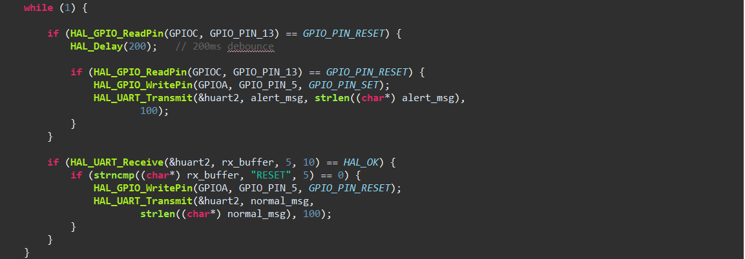

Observation:

- When the system was powered ON, the Red LED remained OFF, indicating normal condition.
- When the emergency push button was pressed, the Red LED turned ON after a short delay (around 200 ms).
- The message "ALERT: Conveyor_Stopped" was successfully transmitted to the serial monitor through UART.
- The 200 ms debounce delay prevented false triggering due to button bouncing.
- When the command "RESET" was sent through the serial terminal, the Red LED turned OFF.
- The message "SYSTEM_NORMAL" was transmitted after receiving the reset command.
- The system remained responsive to UART communication even during button press handling.
- No unexpected behavior or multiple triggers were observed during testing.

Result :

The system correctly detected the emergency button press with 200 ms debounce and activated the Red LED. It transmitted the message "ALERT: Conveyor_Stopped" through UART during emergency condition.
Upon receiving the "RESET" command, the system turned OFF the Red LED and transmitted "SYSTEM_NORMAL", restoring normal operation.

System Designed ;

